NOTICE
DATE:01/03/2023

It is hereby notified that we are going to observe “World Kidney Day (9th March, 2023)”on 14.03.2023 at 3:30 pm, Room No.- 135 in the Dept. of Nutrition, Mugberia Gangadhar Mahavidyalaya. All the B.Sc. (Honours & General), B.Voc (Food Processing), and M.Voc (Food Technology, Nutrition and Management) students and faculties of the Dept. of Nutrition, are informed to attend this programme positively.

Head Principal
Dept. of Nutrition Mugberia Gangadhar Mahavidyalaya
Mugberia Gangadhar Mahavidyalaya

Report of “World Kidney Day ” celebration
The purpose behind celebrating this day is to make students and people aware about good health and nutritious food. Students and people understand the importance of a healthy body and aim at adopting a healthy lifestyle. Nutrition is a basic necessity to lead a healthy life. The goal of National Nutrition Day celebration is to build a healthy Nation.
The purpose of celebrating the day is to raise awareness about the importance of kidneys to overall health and to reduce the frequency and impact of kidney disease and its associated health problems across the globe. In 2006, World Kidney Day was observed for the first time, and since then it has been celebrated every year. It is said that worldwide, 1 in 10 people is affected by kidney disease. “World Kidney Day” is a joint initiative of the International Society of Nephrology (ISN) and the International Federation of Kidney Foundations (IFKF). So our Department of Nutrition observed “World Kidney Day (9th march 2023)” on 14th march 2023 at 3:30 p.m. with 47 students (4 male and 43 female ) and our faculty members . In line with this year’s theme of “Kidney Health for All”, our 2 students of B.Sc. Nutrition Honours were presented their topic named as “ Chronic kidney failure” through power point presentation. The program was successfully completed.

PHOTO:
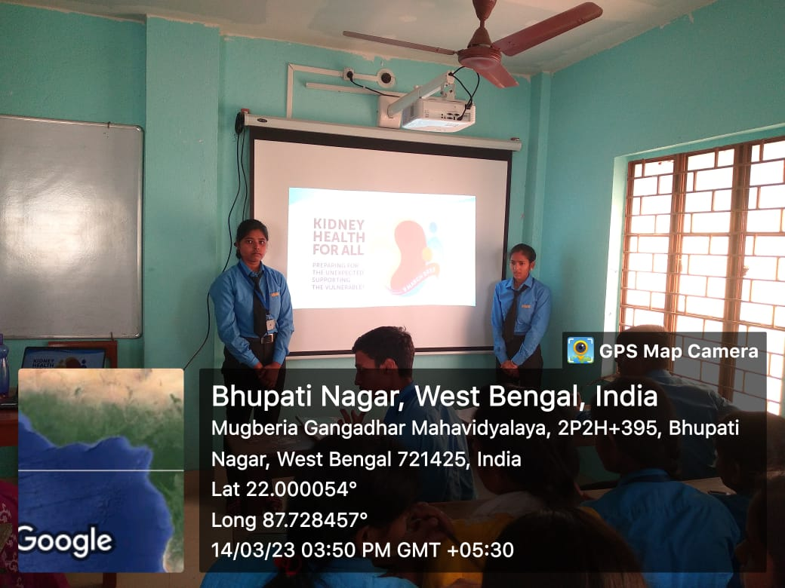
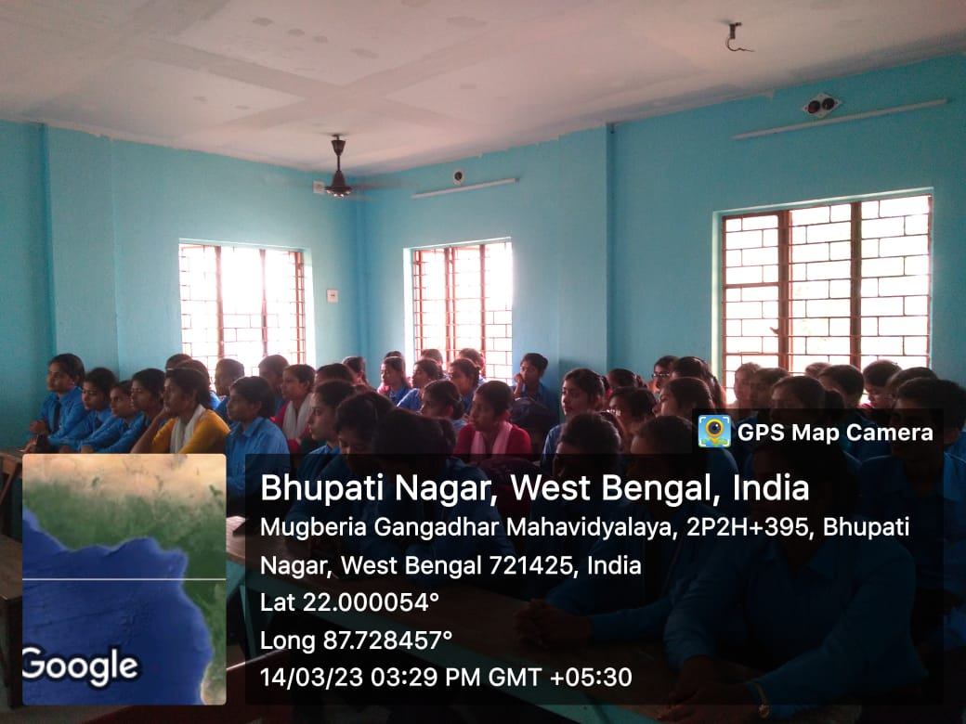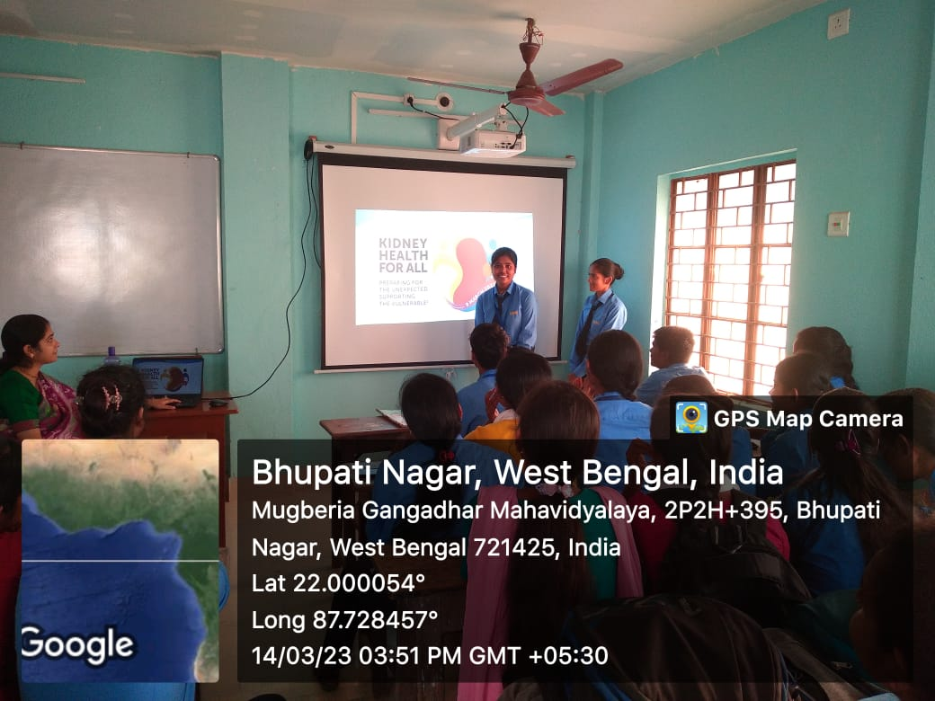

A Attendance of Students:

